**IM3080 Design and Innovation Project (AY2021/22 Semester 1)**

**Individual Report**

Name: Megan Liow Song Ting

Group No: 2

Project Title: Float

**React Native:**

**Reward screen:**

With help from Violin and Amanda, coded overall user interface (UI) of screen, mainly tab bar and its individual tabs (Background, Hat, Accessories, Vouchers), Reward Cards and modals with JSX styling and functions (map, state, props, etc.).

**Profile 2.0 screen:**

Libraries: [Moment](https://www.npmjs.com/package/react-moment), [Calendar Picker](https://www.npmjs.com/package/react-native-calendar-picker), [Bottom Drawer](https://www.npmjs.com/package/react-native-bottom-drawer-view)

Coded overall UI of screen, mood tracker calendar and pull-up tab for user to access chat and journey with JSX styling.

**Check-in screen:**

Libraries: [Moment](https://www.npmjs.com/package/react-moment)

Coded overall UI of Mood Cards, current time, and modal with JSX styling and mapping functions (map, state, props, etc.).

**Exhibition poster:**

Designed using Adobe Illustrator and Canva.

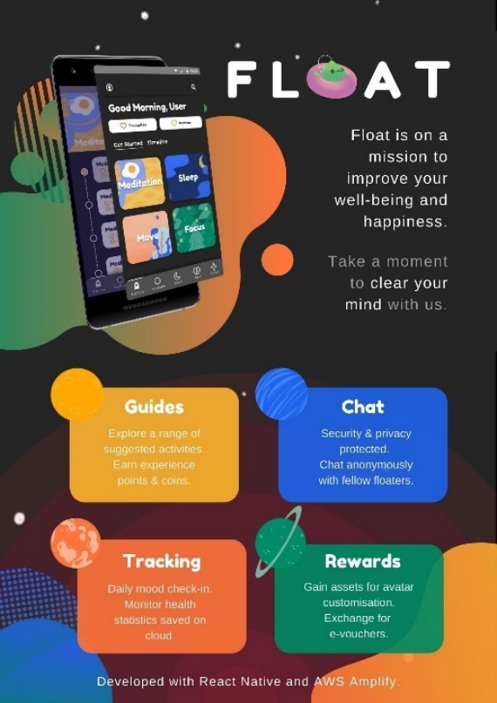

**Reflection on Learning Outcome Attainment**

**Reflect on your experience during your project and the achievements you have relating to at least two of the points below:**

1. Engineering knowledge
2. Problem Analysis
3. Investigation
4. Design/development of Solutions
5. Modern Tool Usage
6. The Engineer and Society
7. Environment and Sustainability
8. Ethics
9. Individual and Team Work
10. Communication
11. Project Management and Finance
12. Lifelong Learning

**Point 1: Engineering knowledge/Problem Analysis**

I had no experience in coding using React Native in mobile development and it seemed daunting to learn the language from scratch at the beginning. Reading up on documentation, watching tutorial videos and analyzing existing open-source codes helped me to understand the concepts a lot better for me to be able to implement the necessary features. I also had to make decisions on which libraries were suitable to be used for integration into the application and experiment with the configurations provided.

**Point 2: Individual and Team Work**

As mentioned, since React Native is new to me, I had to read up documentation of key ideas like components, props, states, hooks, navigation, etc. and understand such concepts within a short period of time. It was also my interest and responsibility to ask questions regarding React Native to expedite my own learning process.

I was also given the opportunity to lead the development of several screens and learnt to collaborate with those working in backend development (regarding API requirements). I also learnt to write neater, more efficient code from more experienced programmers and the functions of Github, an important collaborative tool that enables everyone to know what has been or has not been done/fixed. I presented a few times as well and shared the progress of the project.

Overall, I am thankful given the chance to be part of the frontend development of this project and being able to work well with my teammates.